Machine Problem (Python): Problem 3

Python Script file

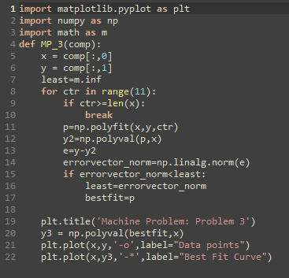

Creating an Array of n\*2 for input

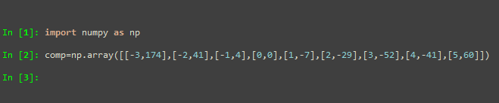

Array comp

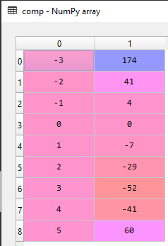

Outputted plot

